1150070015 Ngô Thành Hữu

Lab 4:

- Tạo dự án mới, New Project > Empty Views Activity > đặt tên lab4th > Finish.

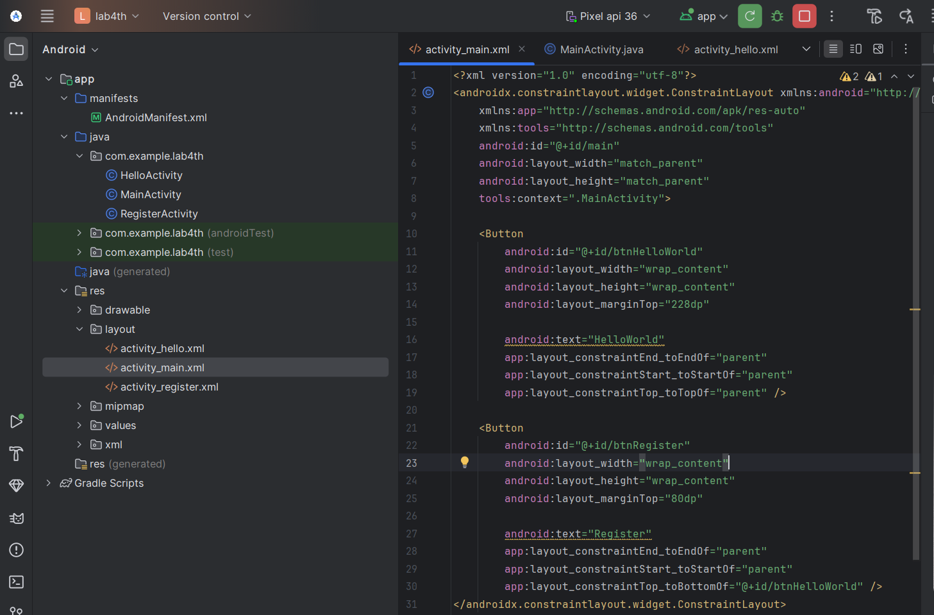

<?xml version="1.0" encoding="utf-8"?>  
<androidx.constraintlayout.widget.ConstraintLayout xmlns:android="http://schemas.android.com/apk/res/android"  
 xmlns:app="http://schemas.android.com/apk/res-auto"  
 xmlns:tools="http://schemas.android.com/tools"  
 android:id="@+id/main"  
 android:layout_width="match_parent"  
 android:layout_height="match_parent"  
 tools:context=".MainActivity">  
  
 <Button  
 android:id="@+id/btnHelloWorld"  
 android:layout_width="wrap_content"  
 android:layout_height="wrap_content"  
 android:layout_marginTop="228dp"  
  
 android:text="HelloWorld"  
 app:layout_constraintEnd_toEndOf="parent"  
 app:layout_constraintStart_toStartOf="parent"  
 app:layout_constraintTop_toTopOf="parent" />  
  
 <Button  
 android:id="@+id/btnRegister"  
 android:layout_width="wrap_content"  
 android:layout_height="wrap_content"  
 android:layout_marginTop="80dp"  
  
 android:text="Register"  
 app:layout_constraintEnd_toEndOf="parent"  
 app:layout_constraintStart_toStartOf="parent"  
 app:layout_constraintTop_toBottomOf="@+id/btnHelloWorld" />  
</androidx.constraintlayout.widget.ConstraintLayout>

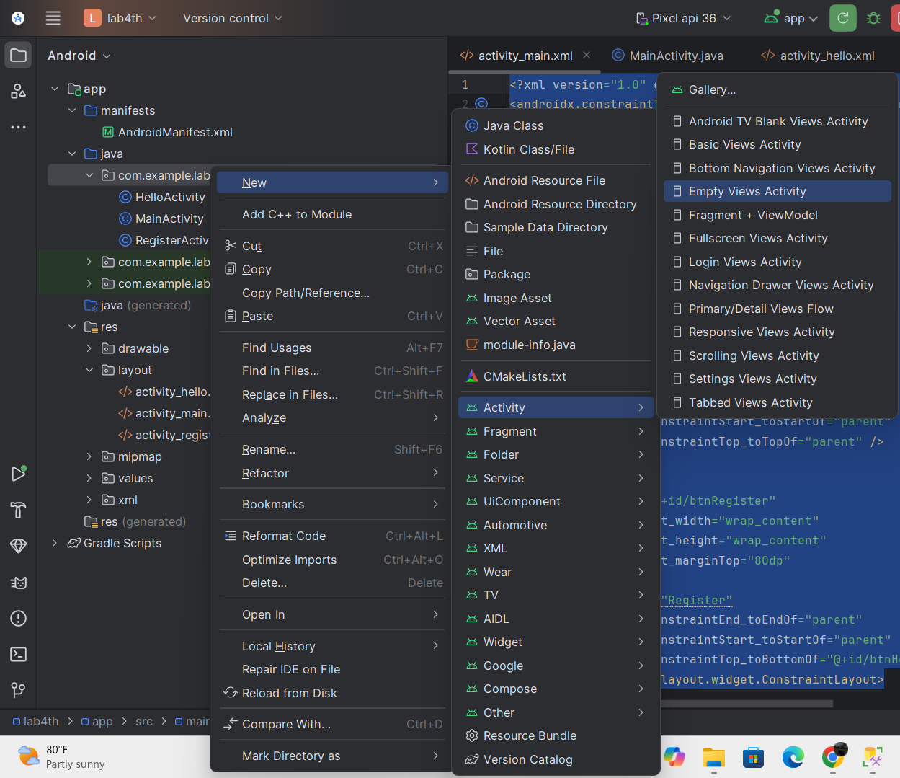

 chuột phải vào thư mục java > New > Activity > Empty Views Activity > đặt tên HelloActivity; làm tương tự cho RegisterActivity.

TRONG mainfesh:

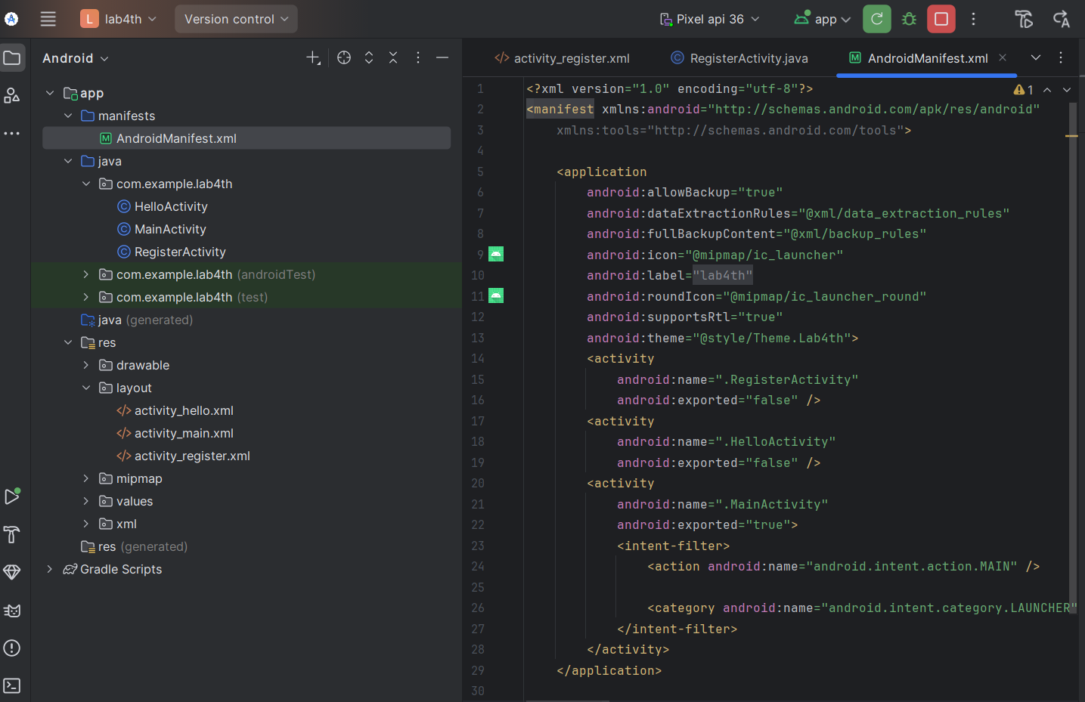

Kết quả :

**Bài 1: Đăng ký BroadcastReceiver bằng code. Tạo ứng dụng nhận tin nhắn**

**Dimes**

**String**

**Mainfesh**

**Mainactivity**

package com.example.lab4th;  
  
import android.os.Build;  
import android.os.Bundle;  
import android.widget.TextView;  
import android.widget.Toast;  
  
import android.content.Context;  
import android.content.Intent;  
import android.content.IntentFilter;  
import android.content.BroadcastReceiver;  
import android.telephony.SmsMessage;  
  
import androidx.appcompat.app.AppCompatActivity;  
  
public class MainActivity extends AppCompatActivity {  
  
 // Khai báo biến (giống slide)  
 private BroadcastReceiver broadcastReceiver;  
 private IntentFilter filter;  
  
 @Override  
 protected void onCreate(Bundle savedInstanceState) {  
 super.onCreate(savedInstanceState);  
 setContentView(R.layout.*activity_main*);  
  
 // Khởi tạo broadcastReceiver (giống slide)  
 initBroadcastReceiver();  
 }  
  
 // Tự động đăng ký/hủy đăng ký khi Resume/Stop (giống slide)  
 @Override  
 protected void onResume() {  
 super.onResume();  
 // Make sure broadcastReceiver was created  
 if (broadcastReceiver == null) initBroadcastReceiver();  
  
 // Register Receiver  
 registerReceiver(broadcastReceiver, filter);  
 }  
  
 @Override  
 protected void onStop() {  
 super.onStop();  
 // UnregisterReceiver when app is destroyed  
 unregisterReceiver(broadcastReceiver);  
 }  
  
 // Xây dựng hàm khởi tạo broadcastReceiver (giống hình)  
 private void initBroadcastReceiver() {  
 // Create filter to listen to incoming messages  
 filter = new IntentFilter("android.provider.Telephony.SMS_RECEIVED");  
  
 // Create broadcastReceiver  
 broadcastReceiver = new BroadcastReceiver() {  
 // Process when a message comes  
 @Override  
 public void onReceive(Context context, Intent intent) {  
 processReceive(context, intent);  
 }  
 };  
 }  
  
 // Xây dựng hàm xử lý khi tin nhắn đến (giống hình)  
 public void processReceive(Context context, Intent intent) {  
 Toast.*makeText*(context, getString(R.string.*you_have_a_new_message*),  
 Toast.*LENGTH_LONG*).show();  
  
 TextView tvContent = (TextView) findViewById(R.id.*tv_content*);  
  
 // Use "pdus" as key to get message  
 final String SMS_EXTRA = "pdus";  
 Bundle bundle = intent.getExtras();  
 if (bundle == null) return;  
  
 // Get array of messages which were received at the same time  
 Object[] messages = (Object[]) bundle.get(SMS_EXTRA);  
 if (messages == null) return;  
  
 String sms = "";  
 SmsMessage smsMsg;  
  
 for (int i = 0; i < messages.length; i++) {  
 if (Build.VERSION.*SDK_INT* >= 23) {  
 // format có thể null, để "" giống slide  
 smsMsg = SmsMessage.*createFromPdu*((byte[]) messages[i], "");  
 } else {  
 smsMsg = SmsMessage.*createFromPdu*((byte[]) messages[i]);  
 }  
  
 // Get message body  
 String msgBody = smsMsg.getMessageBody();  
 // Get source address of message  
 String address = smsMsg.getDisplayOriginatingAddress();  
  
 sms += address + ":\n" + msgBody + "\n";  
 }  
  
 // Show messages in textview  
 tvContent.setText(sms);  
 }  
}

**Activity_main.xml**

Kết quả

**2. Bài 2: Sử dụng BroadcastReceiver đăng ký trong AndroidManifest để tạo ứng dụng nhận biết trạng thái sạc pin/ không sạc pin.**

**String:**

**Them: <string name="power_connected">Power connected</string>  
<string name="power_disconnected">Power disconnected</string>**

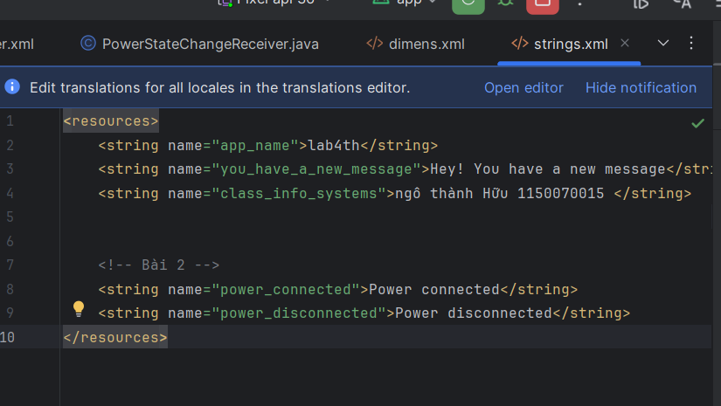

PowerStateChangeReceiver

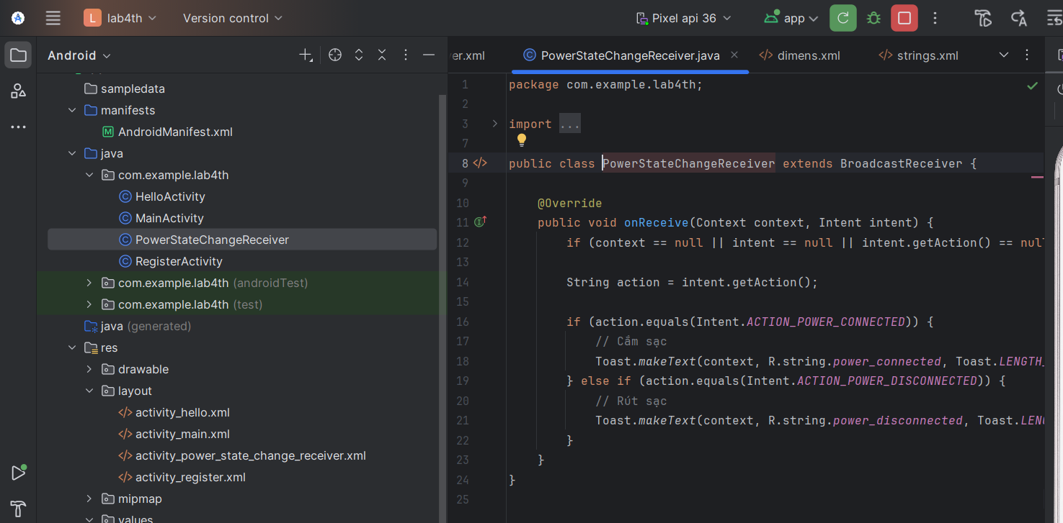

Mainfesh:

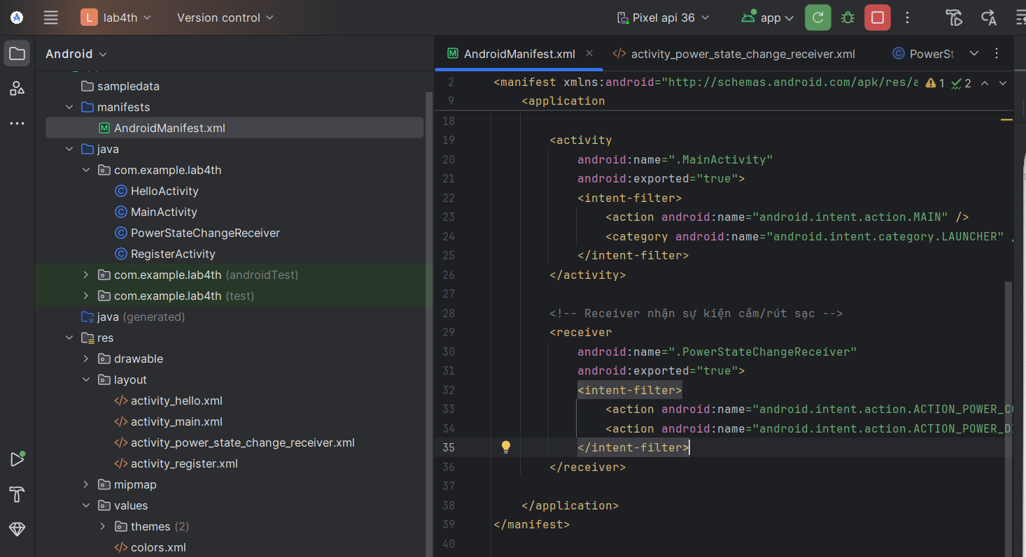

Ket quả

